Merchant: Motivity

Demo date: April 23, 2025  
Scoping start date: April 28, 2025

MSA Signature Date: May 19, 2025  
Onboarding Kick Off Date: June 25, 2025

[If Exists] Opt Out Date: None  
Go Live Date: August 1, 2025

GTM POC: Kat  
Implementation POC: Stephanie

ERP: QBO

Tax Integration: Avalara (Haven’t bought yet but they are going to)

Key people at Merchant

* CFO of Zeroto20: Howard Greene
* VP of Ops of Zeroto20: Jason Prybylo
* Controller of Zeroto20: Barbara Moran
* Head of Accounting of Motivity: Sabrina Gaughran
* AR Specialist of Motivity: Ashley Arsenault
* Director of HR & Operations of Motivity: Christy Evanko
* Chief Creative Officer: Brian Curley

| Notes Sections [Ops International Team to Ignore] *(AE/ Implementation to fill)*   * Info on how merchant bills   + Sales team uses HubSpot (all moving to HubSpot for this year → getting rid of custom built systems) and a custom quote app to generate contracts.   + Contracts are sent for signature via DocuSign.   + Once signed, Ashley manually sets up the customer (Stripe ID) and subscription based on the contract in Stripe. Contracts are supposed to move through a custom built app but sometimes they don’t automatically move through.   + Ashley then handles the entire collections process: she collects based on the term of the contract, Stripe will resend the invoice to them immediately when it is passed due but Ashley is also sending emails.   + Usage data is collected via script and moved into Stripe on the invoices.   + All revenue recognition, reconciliation, and reporting are done manually in Excel.   + Reconciliation with QuickBooks is manual.   + Base subscriptions are billed in advance, usage charges are billed in arrears (learner activity is counted post-period and the difference over the base amount is billed)   + Currently operate on month to month contracts but they will move forward with annual agreements   + Proof of Value periods are common before the full contract begins (3 months typically followed by a 12 month contract)   + Credits, discounts, and contract amendments are tracked manually, often leading to errors or missed adjustments. * Is there any important merchant relationship information?   + Zeroto20 has officially invested in Motivity. While Motivity will continue to operate as a distinct entity, Howard, Zeroto20’s CFO, will remain actively involved in making key business decisions and how the company runs.   + It’s important to note that Howard has expressed uncertainty regarding Sabrina and Ashley’s roles in the organization going forward. Given the sensitivity of this situation, it will need to be approached with care and discretion. I will be in direct communication with Howard to determine whom he would like to appoint to lead the implementation and onboarding efforts.   + Partnership play here. Howard will bring other companies if the experience is great! * What is the merchant temperament?   + Howard: Very, very straight to the point. Direct. Blunt.   + Sabrina: Kind. Detailed oriented. Asks a lot of questions. Perfectionist.   + Ashley: One handling the day to day. Better understanding of what’s going on than Sabrina.   + Brian: have not met yet * Is there a key POC: (i.e.: who is the buyer/decision maker?)   + Howard is the buyer and decision maker.   + Barbara and Jason are part of the decision making process and we did need final sign off from them.   + Coaches: Sabrina & Ashley (the ones handling the process day to day).   + Brian: Head of Implementation * What are the Tabs features that the key POC cares about?   + Howard will care about rev rec and reporting (specifically data having to do with month end close and unbilled versus deferred revenue tracking).   + In general:     1. Contract Ingestion: Uses AI to extract contract terms directly from signed documents (DocuSign, etc.), supporting complex and custom contracts.     2. Integration: Direct integrations with HubSpot, Salesforce, DocuSign, QuickBooks, Stripe.     3. Billing & Revenue Recognition: Automates invoice creation, dunning, collections, and revenue recognition (including deferred, unbilled, and usage-based revenue).     4. Cash Forecasting: Provides accurate, behavior-based cash forecasting and ARR reporting.     5. Visibility: Centralizes data, providing real-time tracking of invoice status, payments, and contract compliance.     6. Implementation: White-glove onboarding, with a typical QuickBooks integration |
| --- |

Summary of what company does:  
  
Motivity is a rapidly growing company that provides a SaaS-based platform, primarily focused on delivering learning or training solutions to clients. Their business involves managing subscriptions for "learners," and they have recently launched a new product, leading to more custom contracts and complex billing arrangements. Motivity has grown from 200 to 600 customers in the past year and recently received its first major investment after being bootstrapped for a decade.

**Goals** (North star)  
*(AE/ Implementation to fill)*

What is the merchant's goal? What pain are we solving? Why are they buying Tabs?

* Goal
  + Scale operations efficiently as they grow from ~600 to 1,000+ active customers.
  + Replace manual processes with automated, accurate systems to handle billing, credits, revenue recognition, and forecasting.
  + Provide real-time, trustworthy financial reporting to new leadership and investors.
  + Gain visibility and control over a highly complex, evolving contract and billing model.
  + Establish a single source of truth across contracts, billing, and revenue systems.
* Pain
  + Manual, Fragmented Processes
    - Heavy reliance on Excel for revenue recognition, credit tracking, forecasting.
    - No connection between billing (Stripe), CRM (HubSpot), and accounting (QuickBooks).
    - Journal entries and cash reconciliation done manually.
  + Limitations and Frustrations with Stripe
    - Stripe doesn’t allow preview or editing of invoices before sending.
    - Credit handling is severely limited (e.g., can't apply a prorated credit or roll forward a credit).
    - No support for revenue recognition, unbilled tracking, or cash application.
    - Manual effort required to match Stripe payouts to customers.
  + Investor & Leadership Pressure
    - Howard wants cash and revenue forecasting.
    - Internal finance team is growing, and expectations for systematized processes are rising.
    - They need to inspire confidence internally and externally in their reporting.

Is there an opt out clause? If so, what is the merchant looking for so they do not exercise it?

None.

**Billing model**

*(AE/ Implementation to fill)*

Are there unique things about the customer creation process for this merchant?

* Stripe as billing and payment processor — but heavily customized and "not a complete view of anything" according to Sabrina. Stripe is used for subscriptions and to capture usage-based charges, but it lacks revenue recognition and credit tracking tools.
* Subscriptions in advance, usage in arrears: A base subscription fee is charged upfront and usage (e.g., number of active learners) is billed after the fact.
* Manual credit management: Credits and discounts are manually tracked and applied — Stripe often fails to apply them automatically even when configured, requiring refunds or manual adjustments.
* Not all customers are on autopay: 93–95% of payments go through Stripe, but some are via check or ACH. Stripe takes a cut of all invoice payments, so large ACH payments are preferred when possible.
* Disconnected AR and accounting: Stripe is not connected to QuickBooks, leading to fully manual AR reconciliation and journal entries at month-end
* A custom script runs monthly to count the number of active learners from the platform. We will pipe in their usage data via API.

How contract is broken up

* Proof of Concept (PoC): Initial short-term (e.g., 3-month) contract to test the system.
* Annual contracts: After PoC, customers often transition into 12-month agreements.
* Line items for implementation, training, and usage tiers are included in contracts but not always enforced.
* Auto-renewal clauses are common

One off things to know about the merchant

* Massive scaling: From 200 to 600 customers in one year, with expectations to hit 1,000 invoices/month by the end of the year.
* Unusual credit structures: Example: issuing credits for unused seats to be carried forward across months/years, or rolling credits over time (e.g., “10 seats/month free”).
* Unclear revenue/cash forecasting history: They have never had formal budgeting or forecasting — it’s now being demanded by investors.

**Contract Processing Steps**

**General Rules**

* Do not add late fees to invoices.
* Do not add charges for additional training and implementation unless explicitly listed as a separate, recurring line item.
* **Net Terms**: If the contract specifies net terms (e.g., "net 30"), use that value. If no terms are listed, default to Net Terms = 0. Make sure you look in detail in the contract. The wording may be different.
* **Billing Contact**: The billing address and email should be pulled and already in the Garage. **Verify** this information against the contract. If the information is missing, use the details provided in the contract itself to fill it.
* **Also for Auto-renewals**: They have 2 types of contracts: annual vs. month to month:
  1. for annual, do not auto-renew
  2. for month-to-month, these should go on forever (will renew)

**Locate Billing Terms (BTs):**

* Typically found in an Order Form or Services Table within the contract.
* Review all listed phases or terms (e.g., transition access, enterprise license) and capture each as a separate BT.

**Billing Term (BT) Setup**

**Service Start Date:**

* Use the start date of the service period as listed in the contract (e.g., "License Start Date").
* If a specific start date isn't listed, use the last signature date on the contract.

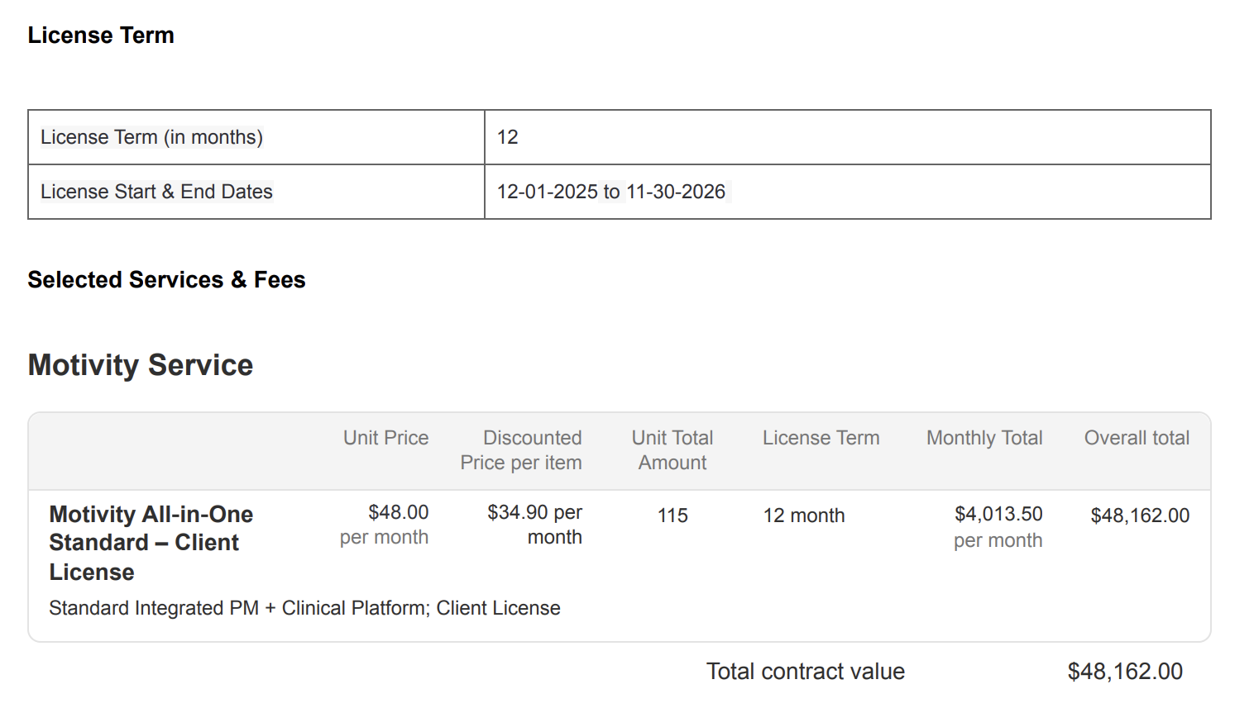

**Months of Service:**

* Use the duration explicitly stated in the contract's "License Term".
* If the contract has autorenewal language (usually in “additional terms” section), please create a separate BT for an additional term

**Product, Pricing, and Item Setup**

For each primary service on an order form/contract, you will create **two** Billing Terms (BTs): one for the included service and one for overages.

**1. Included Service BT**

* **Item Name**: Use the service name exactly as specified on the order form (e.g., "Motivity All-in-One - Client License").
* **Item Description:** Not necessary.
* **Billing Type**: Flat Price.
* **Quantity**: Use the quantity specified in the contract.
* **Total Price**: Use the specified Monthly total in the contract. Usually you can find it in the contract order form.
* **Frequency**: Set according to the contract (e.g., Monthly, Quarterly, Annual).
* **Period:** Typically you can determine using frequency and term. If frequency monthly and term is 12 then period is 12.
* **Billing Timing**: Bill first of period

**2. Overage Service BT**

* **Item Name**: Use the same name as the primary service, but add "Overage" at the end (e.g., "Motivity All-in-One - Client License Overage").
* **Item Description:** Not necessary.
* **Pricing**: This BT must be tiered.
  + **Tier 1**: Set up for the included/base amount of units. The price for this tier is $0.
  + **Tier 2**: Set up for the overage units. The price for this tier is the standard, non-discounted Unit Price from the contract (e.g.,  
    $48.00 per learner/month).
* **Frequency**: Monthly.
* **Event to Track:** There is a predetermined number of units the customer is usually billed for in included service BT, but they can use more if needed. To track this, create an event. The name of the event should match the **item name**.
* Period: Typically you can determine using frequency and term. If frequency monthly and term is 12 then period is 12.
* **Billing Timing**: Billed in arrears to capture the prior month's usage. The usage data will be provided by the merchant.

**Integration Items:**

* Assign **Integration Items** based on the provided "Integration Items to Product Name" mapping document.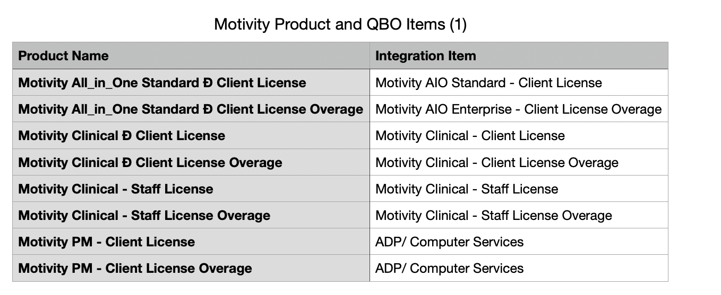

**Amendments**

* Make sure to pay attention to detail. An example in contract 083a4199-5eda-4cd0-be62-9f652e8841a8 There is a discount ($22 instead of $24) in the original motivity service and not on overage (Billed at $24). Important to read carefully.
* Some good examples of processed contracts you can look at in Garage:

(ie. 498e3927-9a20-4672-b9e9-ccb0e7d184c9, 083a4199-5eda-4cd0-be62-9f652e8841a8)



* + Otherwise process BT separately on the amendment contract instance in garage

**Integration / Rev Rec:**

**Examples:**

0da618ce-3760-47ff-9efa-7bd75c176254

c

C2dca849-45d3-47b9-97c8-23a9000448a7

Da9e44d3-19dd-4e63-b9cb-fa708758f020

Anything to ignore in contracts?

Events Processing (if necessary)  
*(Implementation/Success to fill)*

* Any important information on events billing

Integration Items Processing (if necessary)  
*(Implementation/Success to fill)*

* What are the instructions for assigning integration items?
* Example: All Statsig integrations items should be labeled as “Sales”
* Example: All “Pinata” integration items should be labeled as “Software Subscription Bundle” unless otherwise noted by Merchant

Post Processing Communications (if necessary)  
*(Implementation/Success to fill)*

* Does the Ops Team need to notify anyone on the team re: completion of processing batches in Implementation or Active phase?
* Who needs to be notified and when?
  + Example:
    - Who: Customer Success [Azmat Aziz] needs to be notified
    - Where: Messari internal merchant channel
    - When: contracts are processed [Merchant Phase: Active]

Customer Information  
*(Implementation/Success to fill)*

* Any important information on specifics customers of this merchant
  + Special memo’s certain invoices require
  + Invoice changes due to merchant/customer relationship

Feature Requests  
*(AE/Implementation/Success to fill)*

* FR 1
  + What is it
  + Why it's important
  + Urgency

Rewatch Calls  
*(AE/Implementation/Success to fill)*

* Rewatch by dates
  + [Discovery: April 18th](https://us-56595.app.gong.io/call?id=3024920070977672210&account-id=8543852811825646666)
  + [Demo: April 23rd](https://us-56595.app.gong.io/call?id=4525751893057950477&account-id=8543852811825646666)
  + [Demo: April 28th](https://us-56595.app.gong.io/call?id=5218805422936409167&account-id=8543852811825646666)
  + [Demo: April 30th](https://us-56595.app.gong.io/call?id=3081042526552623248&account-id=8543852811825646666)
  + Demo: May 1st (not listed on Gong)
  + [Executive Presentation: May 7th](https://us-56595.app.gong.io/call?id=7198288504374007992&account-id=8543852811825646666)
  + [Demo: May 8th](https://us-56595.app.gong.io/call?id=3855949890728244551&account-id=8543852811825646666)
  + [Proposal: May 12th](https://us-56595.app.gong.io/call?id=4858424983051321203&account-id=7646947261137385962)